**Week – 8**

Simulate all file allocation strategies.

a) Sequential b) Indexed c) Linked.

**Code:**

#include<stdio.h>

#include<stdlib.h>

struct map {

int filename;

int size;

int req;

int start;

int all[100];

};

struct map b1[100];

int k=0;

int w=0;

int link[100];

struct map1 {

int filename;

int size;

int req;

int start;

};

struct map1 b2[100];

int a3[100][100];

struct map3 {

int filename;

int size;

int req;

int index;

};

struct map3 b3[100];

int z=0;

void indexall(int ms,int ds){

int n,j,p,x;

int c;

printf("enter filename:");

scanf("%d",&c);

b3[z].filename=c;

printf("enter file size:");

scanf("%d",&n);

b3[z].size=n;

if(n%ds==0)

j=n/ds;

else

j=(n/ds)+1;

b3[z].req=j+1;

printf("enter index block:");

scanf("%d",&x);

b3[z].index=x;

printf("enter %d values:",j);

for(int i=0;i<j;i++){

scanf("%d",&p);

a3[x][i]=p;

}

printf("filename\tfilesize\tnoofblock\tindex\tallocateblock\n");

printf("%d\t\t%d\t\t%d\t\t%d\t\t",b3[z].filename,b3[z].size,b3[z].req,b3[z].index);

x=b3[z].index;

for(int i=0;i<b3[z].req-1;i++){

printf("%d->",a3[x][i]);

}

z++;

printf("\n");

}

void indexd(int ms,int ds){

int x;

printf("filename\tfilesize\tnoofblock\tindex\tallocateblock\n");

for(int j=0;j<z;j++){

printf("%d\t\t%d\t\t%d\t\t%d\t\t",b3[j].filename,b3[j].size,b3[j].req,b3[j].index);

x=b3[j].index;

for(int i=0;i<b3[j].req-1;i++){

printf("%d->",a3[x][i]);

}

printf("\n");

}

}

void indexds(int ms,int ds){

int x,p;

printf("enter filename:");

scanf("%d",&p);

printf("filename\tfilesize\tnoofblock\tindex\tallocateblock\n");

for(int j=0;j<z;j++){

if(p==b3[j].filename){

printf("%d\t\t%d\t\t%d\t\t%d\t\t",b3[j].filename,b3[j].size,b3[j].req,b3[j].index);

x=b3[j].index;

for(int i=0;i<b3[j].req-1;i++){

printf("%d->",a3[x][i]);

}

}

}

printf("\n");

}

void linall(int ms,int ds){

int n,i,j,past;

int c;

printf("enter filename:");

scanf("%d",&c);

b2[w].filename=c;

printf("enter file size:");

scanf("%d",&n);

b2[w].size=n;

int x;

if(n%ds==0)

j=n/(ds-1);

else

j=(n/(ds-1))+1;

b2[w].req=j;

printf("enter %d values:",j);

for(int i=0;i<j;i++){

if(i==0){

scanf("%d",&x);

b2[w].start=x;

past=x;

}

else{

scanf("%d",&x);

link[past]=x;

past=x;

}

}

link[past]=-1;

printf("filename\tfilesize\tnoofblock\tstartblock\tallocateblock\n");

printf("%d\t\t%d\t\t%d\t\t%d\t\t",b2[w].filename,b2[w].size,b2[w].req,b2[w].start);

x=b2[w].start;

for(int i=0;i<b2[w].req && x!=-1;i++){

printf("%d->",x);

x=link[x];

}

w++;

printf("\n");

}

void lind(int ms,int ds){

int x;

printf("filename\tfilesize\tnoofblock\tstartblock\tallocateblock\n");

for(int i=0;i<w;i++){

printf("%d\t\t%d\t\t%d\t\t%d\t\t",b2[i].filename,b2[i].size,b2[i].req,b2[i].start);

x=b2[i].start;

for(int j=0;j<b2[i].req&&x!=-1;j++){

printf("%d->",x);

x=link[x];

}

printf("\n");

}

}

void linds(int ms,int ds){

int p,x;

printf("enter filename:");

scanf("%d",&p);

printf("filename\tfilesize\tnoofblock\tstartblock\tallocateblock\n");

for(int i=0;i<w;i++){

if(p==b2[i].filename){

printf("%d\t\t%d\t\t%d\t\t%d\t\t",b2[i].filename,b2[i].size,b2[i].req,b2[i].start);

x=b2[i].start;

for(int j=0;j<b2[i].req&&x!=-1;j++){

printf("%d->",x);

x=link[x];

}

}

}

printf("\n");

}

void seqall(int ms,int ds) {

int n,i,j,p;

int c;

int a[ms/ds];

printf("enter filename:");

scanf("%d",&c);

b1[k].filename=c;

printf("enter file size:");

scanf("%d",&n);

b1[k].size=n;

printf("starting point:");

scanf("%d",&p);

b1[k].start=p;

if(n%ds==0)

j=n/ds;

else

j=(n/ds)+1;

b1[k].req=j;

printf("filename\tfilesize\tnoofblock\tstartblock\tallocateblock\n");

printf("%d\t\t%d\t\t%d\t\t%d\t\t",c,n,j,p);

for(i=p;i<p+j;i++) {

printf("%d, ",i);

b1[k].all[i-p]=i;

}

k++;

printf("\n");

}

void seqd(int ms,int ds){

printf("filename\tfilesize\tnoofblock\tstartblock\tallocateblock\n");

for(int j=0;j<k;j++){

printf("%d\t\t%d\t\t%d\t\t%d\t\t",b1[j].filename,b1[j].size,b1[j].req,b1[j].start);

for(int i=0;i<b1[j].req;i++){

printf("%d, ",b1[j].all[i]);

}

printf("\n");

}

}

void seqds(int ms,int ds){

int x;

printf("enter file name:");

scanf("%d",&x);

printf("filename\tfilesize\tnoofblock\tstartblock\tallocateblock\n");

for(int j=0;j<k;j++){

if(x==b1[j].filename){

printf("%d\t\t%d\t\t%d\t\t%d\t\t",b1[j].filename,b1[j].size,b1[j].req,b1[j].start);

for(int i=0;i<b1[j].req;i++){

printf("%d, ",b1[j].all[i]);

}

}

}

printf("\n");

}

void seq(int ms,int ds){

int x,y=1;

while(y==1){

printf("select 1:allocate file 2:display file info 3:display specific file info:");

scanf("%d",&x);

switch(x){

case 1: seqall(ms,ds);

break;

case 2: seqd(ms,ds);

break;

case 3: seqds(ms,ds);

break;

}

printf("enter to cont 1/0:");

scanf("%d",&y);

}

}

void inde(int ms,int ds){

int x,y=1;

while(y==1){

printf("select 1:allocate file 2:display file info 3:display specific file info:");

scanf("%d",&x);

switch(x){

case 1: indexall(ms,ds);

break;

case 2: indexd(ms,ds);

break;

case 3: indexds(ms,ds);

break;

}

printf("enter to cont 1/0:");

scanf("%d",&y);

}

}

void linked(int ms,int ds){

int x,y=1;

while(y==1){

printf("select 1:allocate file 2:display file info 3:display specific file info:");

scanf("%d",&x);

switch(x){

case 1: linall(ms,ds);

break;

case 2: lind(ms,ds);

break;

case 3: linds(ms,ds);

break;

}

printf("enter to cont 1/0:");

scanf("%d",&y);

}

}

void main(){

int ms,ds,x;

printf("enter memory size:");

scanf("%d",&ms);

printf("enter data block size:");

scanf("%d",&ds);

printf("select 1:sequence 2:linked 3:indexed 4:exit:");

scanf("%d",&x);

switch(x){

case 1: seq(ms,ds);

break;

case 2: linked(ms,ds);

break;

case 3: inde(ms,ds);

break;

}

}

**Output for Sequential:**

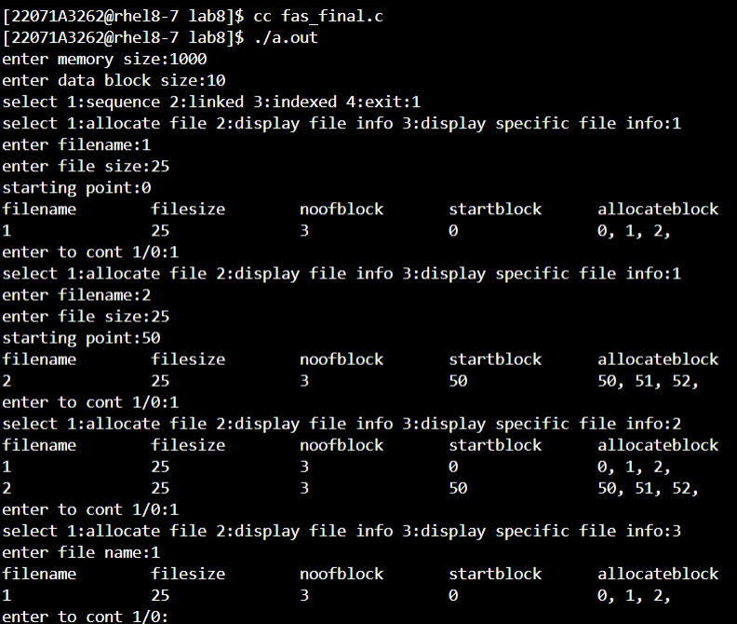

**Output for Linked:**

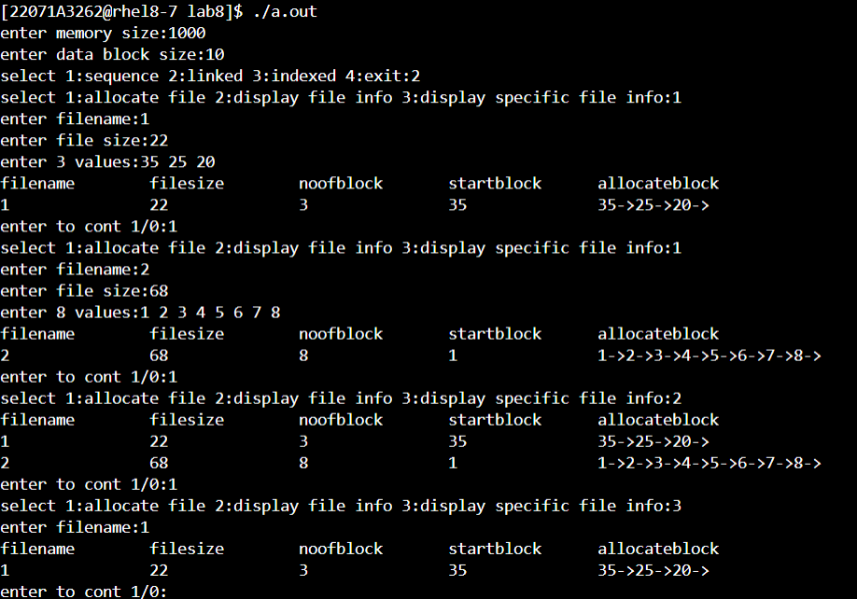

**Output for Indexed:**

